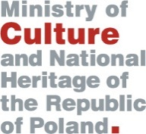
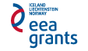


Application Form

for matchmaking seminar within the Program:

Promotion of Diversity in Culture and Arts within European Cultural Heritage

Participant data:

Organization:

Name and Surname:

Job title:

Correspondence address:

Mobile phone/:

Fax:

E-mail:

Thematic area: (to be selected)
Music and stage arts | Fine and visual arts
Cultural heritage | Cultural and artistic education

Estimated Project budget:

Description of the idea

on the project:

Registration deadline: 30 April 2013. All application forms should be sent to the following e-mail address: sekretariat.eog@mkidn.gov.pl

The workshop is free of charge, however travel and accommodation costs shall not be covered by the Ministry of Culture and National Heritage.

Program Operator reserves the right to contact only selected organizations.

